**Scratch Project**

**Introduction:-**

This game is design for children (age: 4-10). The user can use the up arrow keys to move up, right arrow key to move to the right-side and left arrow key to move to the left side.

Naruto (object) has to pass through all these obstacles in order to reach his destination.

**Step 1:** Thumbnail

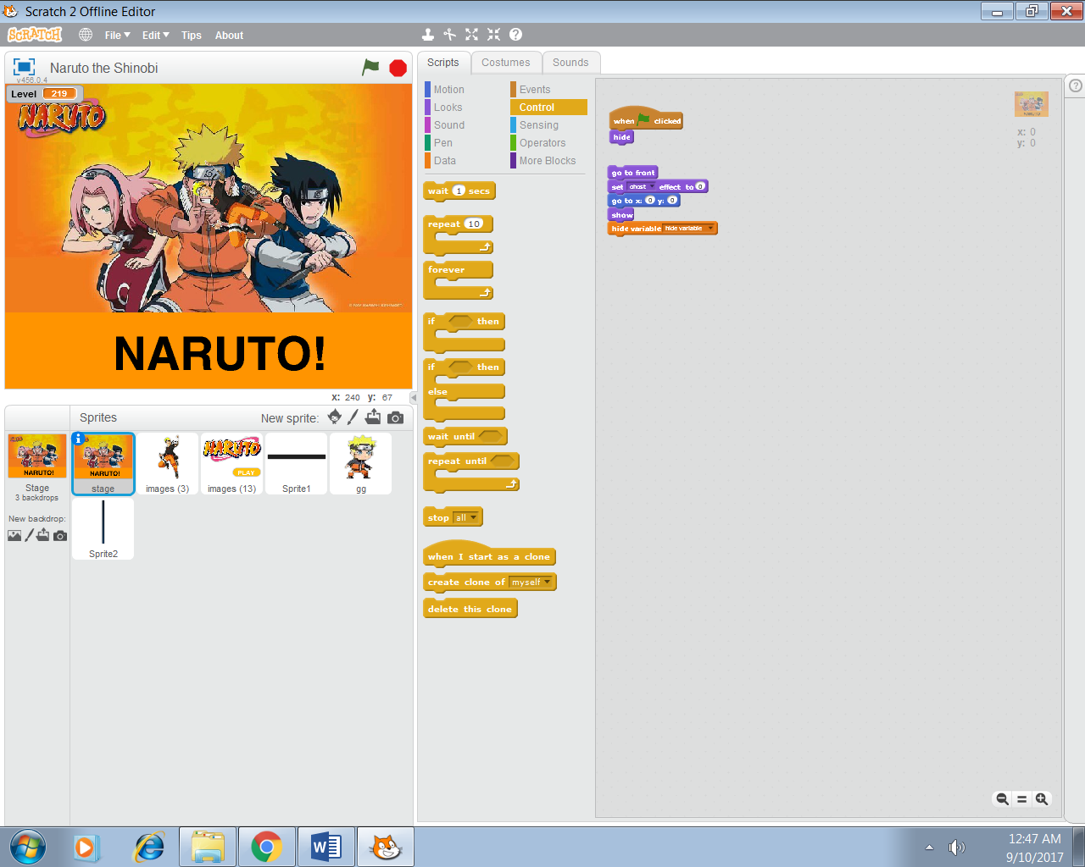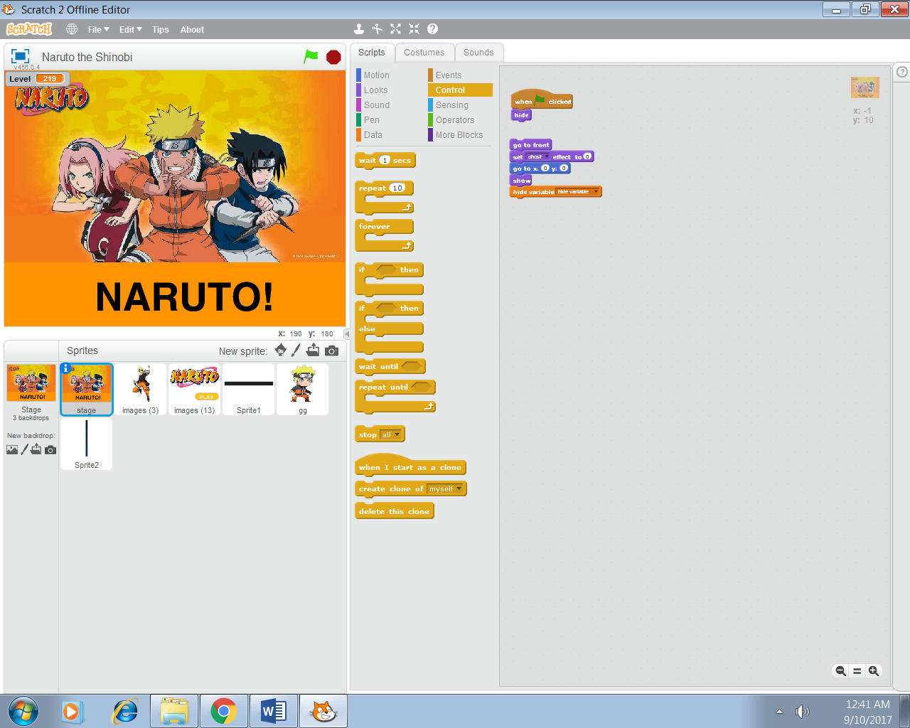

**Step 2:** Floating Icon

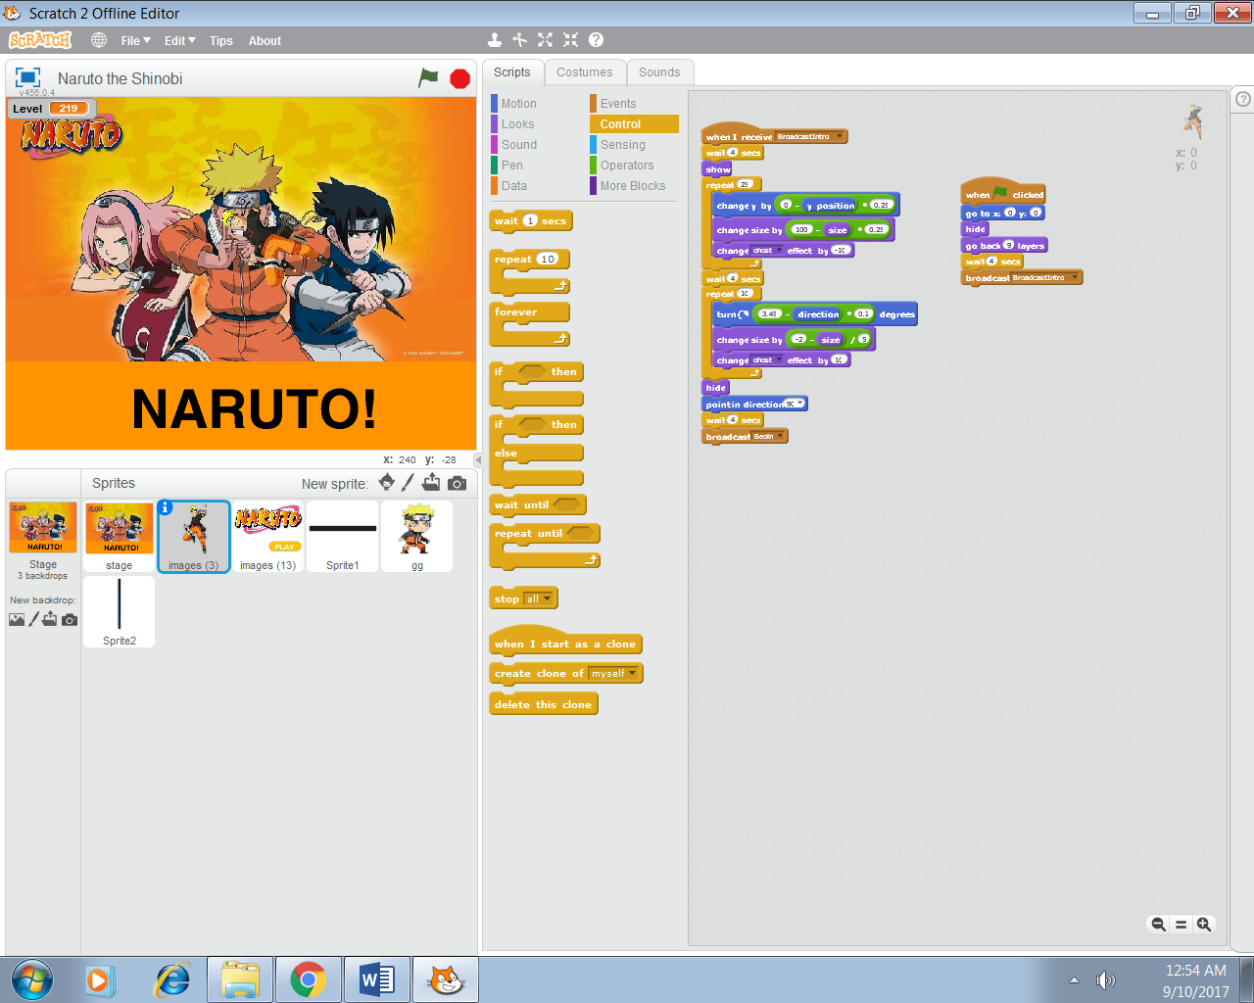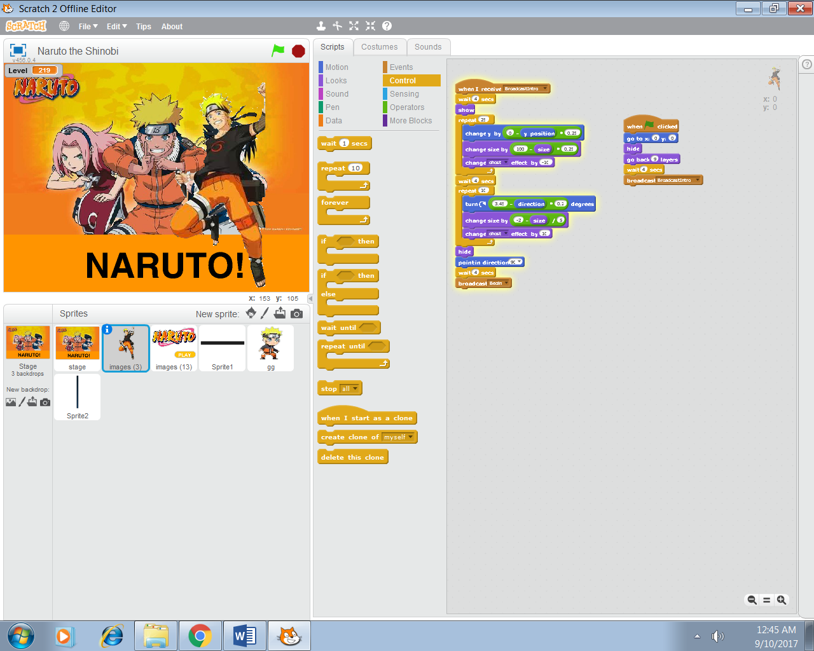

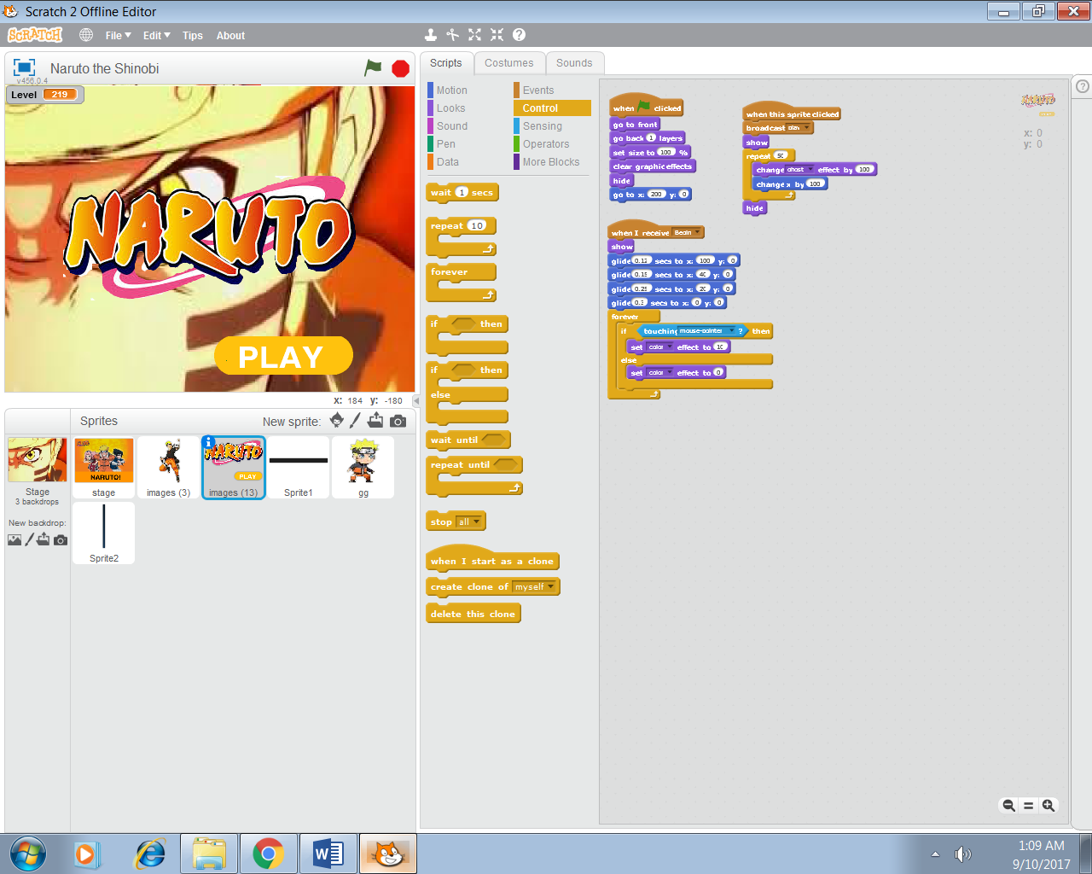**Step 3:** Play

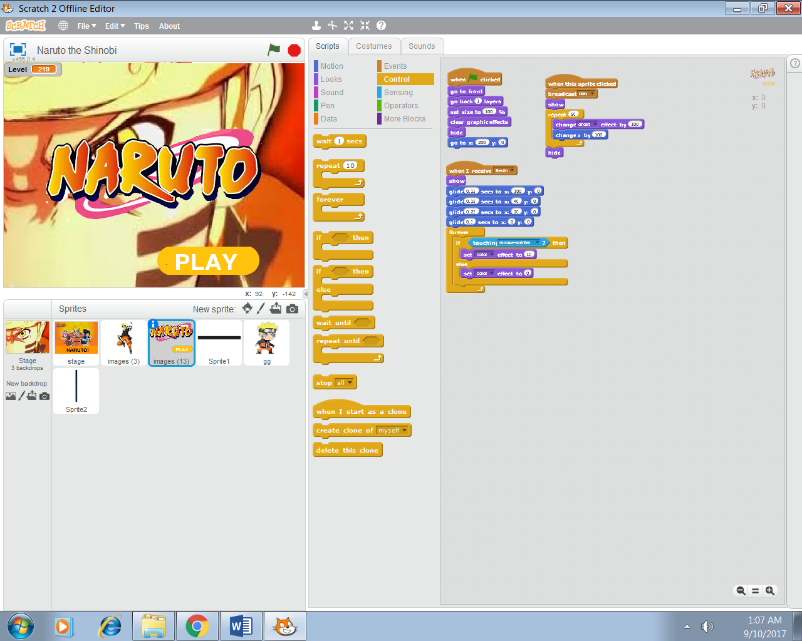

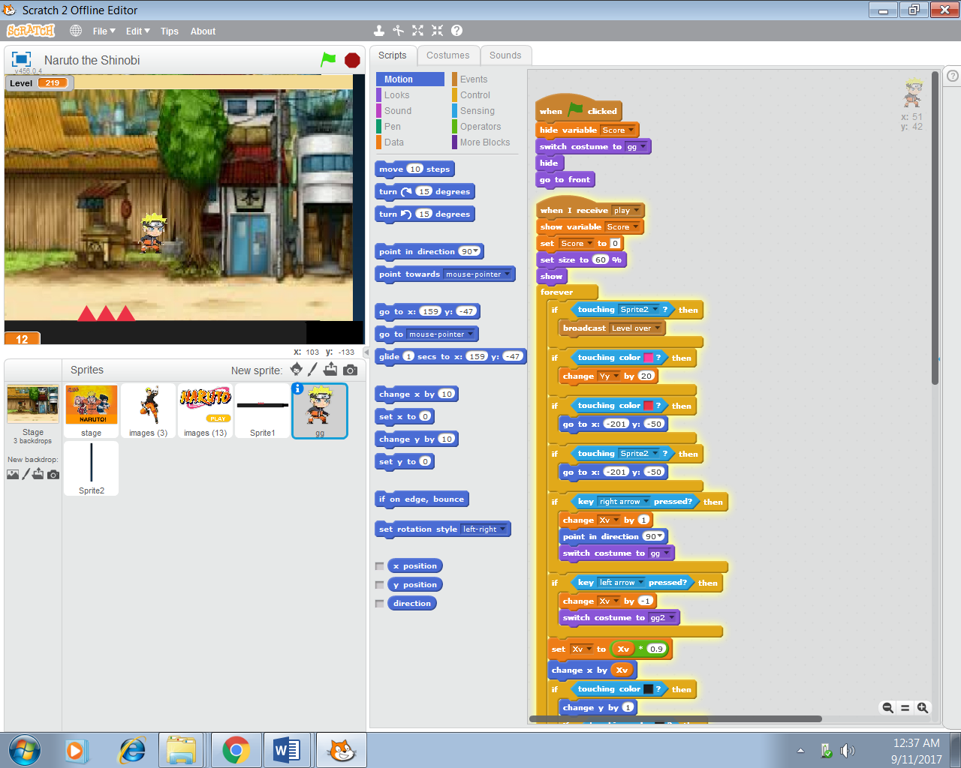**Step 4:** Object



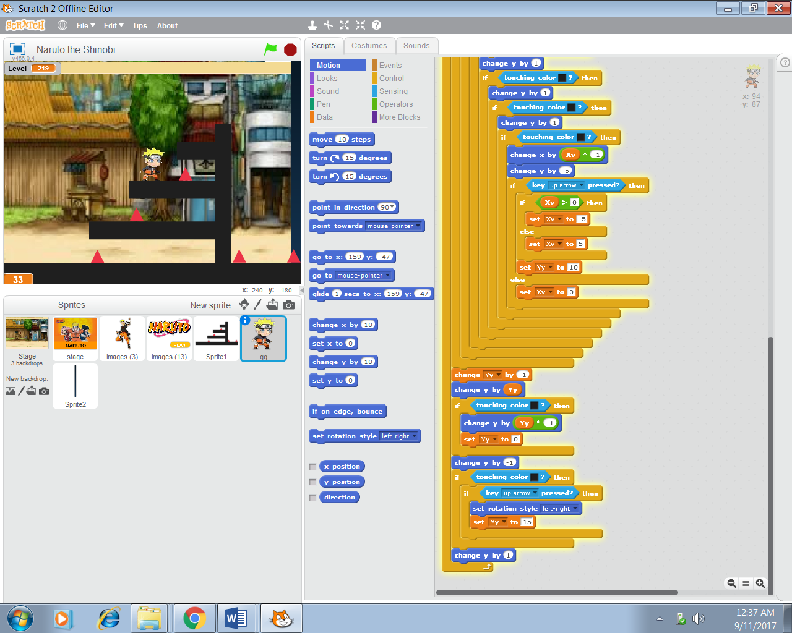

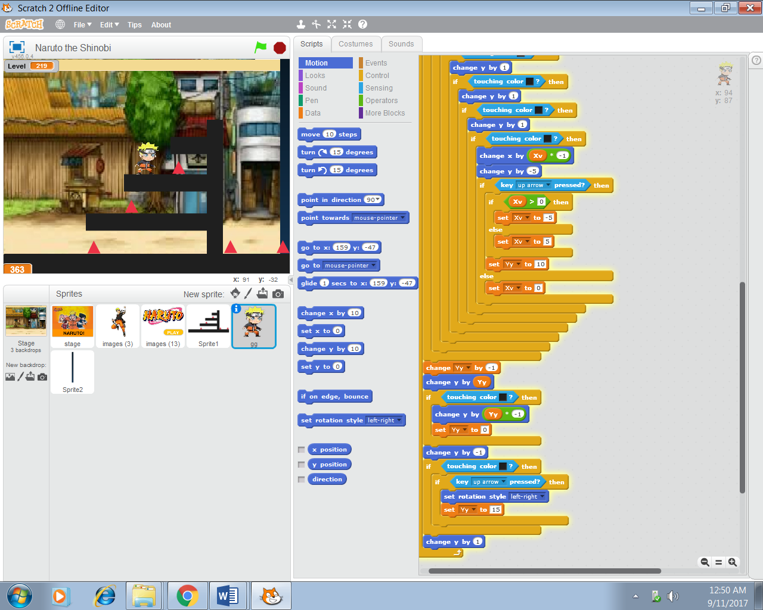



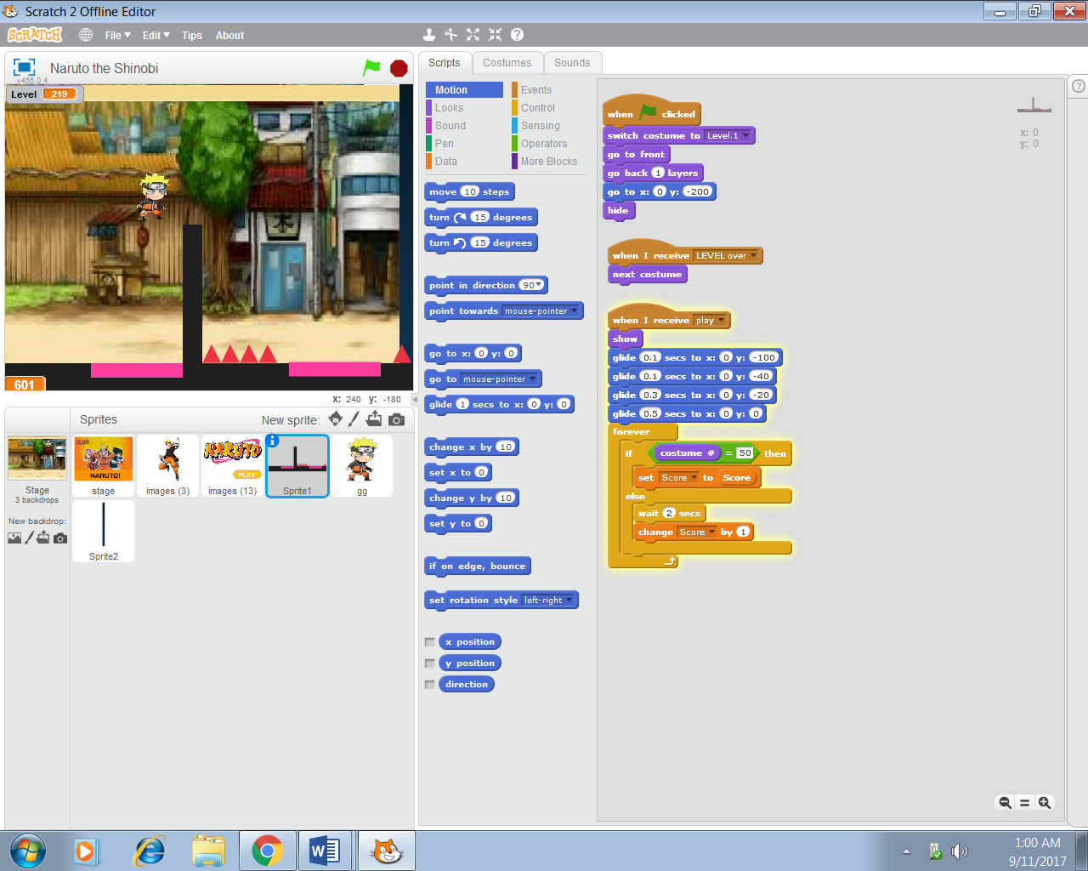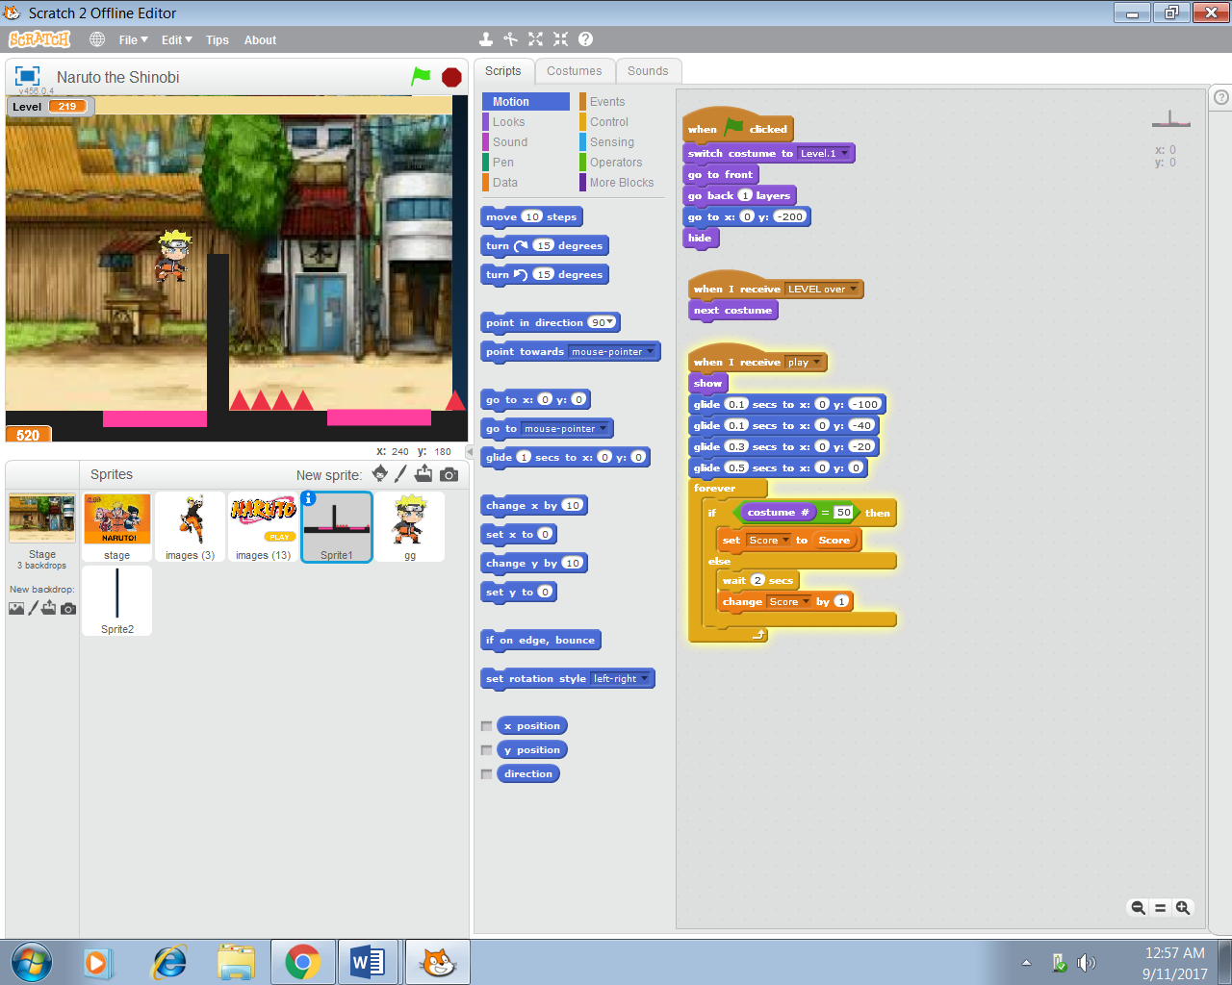**Step 5**: Platform

**Step 6:** Next Level